 **MATHEMATICS: SPECIALIST 1 & 2**

**SEMESTER 2 2019**

**TEST 5**

**Name_____________________**

**Calculator Free**

Time allowed: 34 mins Total marks: 32

**1. [2 marks]**

Write the following recurring decimal as a fraction.

7.1465465465….

**2. [3 marks]**

Sketch the graph of $y=sec3x$ for $0°≤x≤360°$.

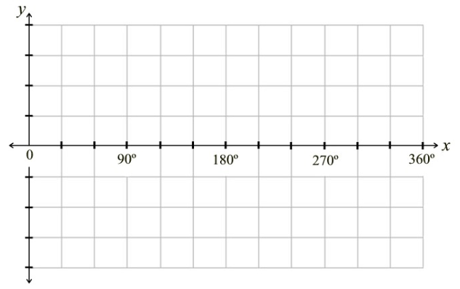

**3. [3 marks]**

Show that when any three odd numbers are added together, the result is an odd number.

**4. [1, 2, 2, 2 = 7 marks]**

Given that $cosA= -\frac{4}{5}$, where A is obtuse, find the exact value of:

$$sinA$$

$$sin2A$$

$$cos2A$$

$$cot2A$$

**5. [2, 5 = 7 marks]**

Prove the following:

a) ${cosec}^{2}x=secx cosecx cotx$

b) $\frac{sinx+cosx}{cosxsinx}=sinx\left(1+tanx\right)+cosx(1+cotx)$

**6. [3 marks]**

Show that:

$$sin11xcos7x-sin8xcos4x=sin3xcos15x$$

**7. [4 marks]**

Fully describe the transformations that take $y=sinx$ to $y=\frac{1}{3}\sin\left(8x-120\right)+4.$

**8. [3 marks]**

Solve $secx=2$, where $x$ is in degrees.



**MATHEMATICS: SPECIALIST 1 & 2**

**SEMESTER 2 2019**

**TEST 5**

**Name_____________________**

**Calculator Assumed**

Time allowed: 28 mins Total marks: 26

**9. [5 marks]**

Prove, using contradiction that $\sqrt{5}$ is irrational.

**10. [3, 3 = 6 marks]**

a) Write $3cosx-5sinx$ in the form $rcos(x+α)$.

b) Hence solve $3cosx-5sinx+2=0$ for $0°≤x≤360°$.

**11. [4 marks]**

Solve $2\sec^{2}x=9tanx+7$ for $0°≤x≤360°$. Give answers to 2 decimal places.

**12. [3 marks]**

Solve the following:

$\tan\left(2x-\frac{π}{6}\right)-1=0$

**13. [1, 1, 3, 3 = 8 marks]**

Juanita is lying on the beach watching the waves. She notices that the waves appear to roll up the beach at regular time intervals, and she is able to estimate the distance of the wave front from her toes over time. She scratches Cartesian axes in the sand and sketches the distance of the wave from her toes against time in minutes. She realises that the distance can be modelled by a sine curve $d=asinbt+c$, with time (t) in minutes along the horizontal axis and distance (d) in metres on the vertical axis.

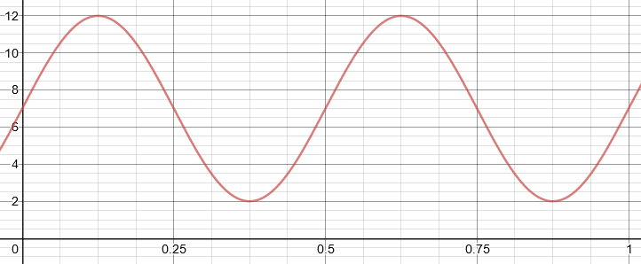

a) State the maximum and minimum distances of the waves from her feet.

b) How many waves wash up on the beach each hour?

c) Find the values of a, b and c.

Her beach umbrella is stuck into the sand 4.5m closer to the wave front than her toes and the waves are washing over its base.

d) Calculate the percentage of time for which the base of the umbrella is in the water.